Technical Requirements

1. Web Access
2. Database jar Libraries
3. Mysql server
4. Software installer

Data Dictionary

**Counselor**

A counselor is anyone who has access to the software. Counselor credentials include counselor id, name, date of birth, address, email, phone number.

**Student**

A student is anyone who’s information is entered into the program with the intent to auto generate a schedule. Student credentials include student id, name, counselor, grade level, current classes, gender, email, phone, date of birth, address, emergency contact.

**Teacher**

A teacher is anyone who’s information is entered into the program with the intent of assigning that person to teach a class. Teacher credentials include teacher id, teacher name, teacher subject.

**Teacher Field**

The teacher field refers to the teacher’s field of study. This is represented by a string that can be but is not limited to MATH, ENGLISH, SCIENCE, HISTORY, etc.

**Student Grade Level**

The student grade level refers to the student’s class status at the school. This is represented by a string which can only be the following: SIXTH, SEVENTH, EIGHTH, FRESHMAN, SOPHOMORE, JUNIOR, and SENIOR.

**Class**

The ‘class’ term refers to a single class with one student assigned to it and has a capacity. Classes can only be created by a counselor. The following fields are required to create a class: CLASS ID, CLASS NAME, TEACHER, ASSISTANT TEACHER, CLASS CAPACITY, and CLASS PERIOD. A counselor may set restrictions to a class when created. These restrictions include student grade level restrictions (i.e. sophomore only) and gender restrictions.

Class Diagram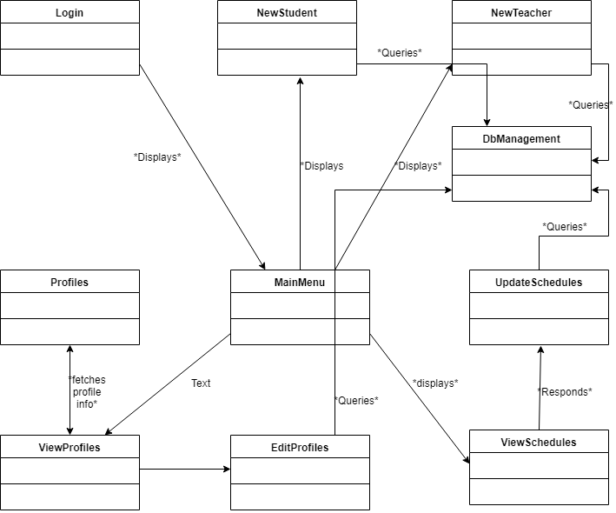

Use Case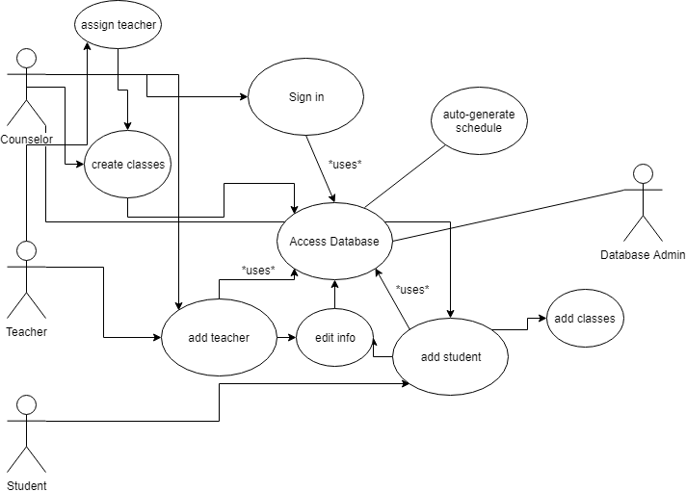

Design Diagram